**Compiler Design Lab**

**Program**

Implementation of Symbol table Report

**Abstract**

**🡪** Symbol table is an important data structure created and maintained by compilers in order to store information about the occurrence of various entities such as variable names, function names, objects, classes, interfaces, etc.

🡪 Symbol table is used by both the analysis and the synthesis parts of a compiler.

🡪 A symbol table is simply a table which can be either linear or a hash table. It maintains an entry for each name.

**Items stored in Symbol table :**

Variable names and constants

Procedure and function names

Literal constants and strings

Compiler generated temporaries

Labels in source languages

**Output of the program :**

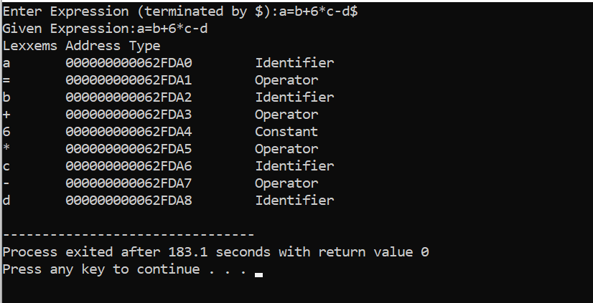

* In the above output the expression contains identifier and operator like +,* . After entering the expression at last click '$' symbol so that compiler understand that the expression has ended.
* Each element in the expression is divided into parts and the type is written seperately for each element and the address is also written seperately for each element.
* Here **a,b,c** are identifiers , and **+,\*** are operators.